**CAPSTONE PROJECT**

**Task 1 – Academic Management System:**

**1. Database Creation:**

create database student_database;

use student_database;

1. **Creating table StudentInfo:**

Create table StudentInfo (

STU_ID int,

STU_NAME varchar(100),

DOB DATE,

PHONE_NO VARCHAR(10),

EMAIL_ID varchar(50),

ADDRESS varchar(250),

primary key (STU_ID));

1. **creating table CourseInfo:**

Create table CourseInfo(

COURSE_ID INT ,

COURSE_NAME VARCHAR(100),

COURSE_INSTRUCTOR_NAME VARCHAR(100),

primary key (COURSE_ID));

1. **creating table EnrollmentInfo:**

Create table EnrollmentInfo(

ENROLLMENT_ID INT,

STU_ID int,

COURSE_ID INT,

ENROLL_STATUS varchar(20),

primary key (ENROLLMENT_ID),

FOREIGN KEY (STU_ID) REFERENCES StudentInfo(STU_ID),

FOREIGN KEY (COURSE_ID) REFERENCES CourseInfo(COURSE_ID));

**2) Data Creation**

a) Insert Into StudentInfo

(STU_ID, STU_NAME, DOB, PHONE_NO, EMAIL_ID ,ADDRESS) Values

('101', 'Virat', '1991-02-13',9898989898, 'Virat123@gamil.com', 'Banglore'),

('102', 'Dhoni', '1984-08-04',9999999995, 'Dhoni201@gamil.com', 'Banglore'),

('103', 'Bhuvi', '1994-08-15',9999999976, 'Bhuvi301@gamil.com', 'Chennai'),

('104', 'Robin', '1994-01-23',9999999669, 'Robin401@gamil.com', 'Mumbai'),

('105', 'John Austin', '1993-06-24',9999993456, 'John501@gamil.com', 'Hyderabad'),

('106', 'Daniel', '1992-07-27',9999997654, 'Dan601@gamil.com', 'Hyderabad');

b) Insert Into CourseInfo(COURSE_ID,COURSE_NAME, COURSE_INSTRUCTOR_NAME) values

(001, 'SQL','Sofy'),

(002, 'Python','Arvind'),

(003, 'AWS','Seema'),

(004, 'JAVA','Harry'),

(005, 'CSS','Jacky');

c) insert into EnrollmentInfo(ENROLLMENT_ID, STU_ID, COURSE_ID, ENROLL_STATUS) values

(10001, 101, 001,'ENROLLED'),

(10002, 103, 002,'ENROLLED'),

(10003, 104, 004,'ENROLLED'),

(10004, 102, 003,'ENROLLED'),

(10005, 105, 003,'NOT ENROLLED'),

(10006, 106, 005,'ENROLLED');

3) **Retrieve the Student Information**

**a) Write a query to retrieve Student details, Such as Student Name, Contact Informations and Enrollment Status**

Select s.STU_NAME, s.PHONE_NO, s.ADDRESS,

e.ENROLL_STATUS

from StudentInfo s join EnrollmentInfo e

on s.STU_ID=e.STU_ID

order by e.ENROLL_STATUS ;

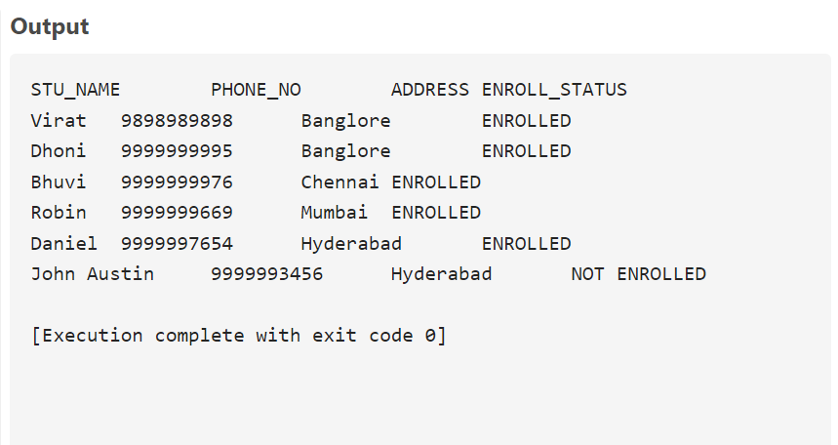

**b) Write a query to retrieve a list of courses in which a specific student enrolled**

select c.COURSE_NAME, s.STU_NAME

from EnrollmentInfo e

join CourseInfo c on e.course_id = c.course_id

join StudentInfo s on s.STU_ID = e.STU_ID;

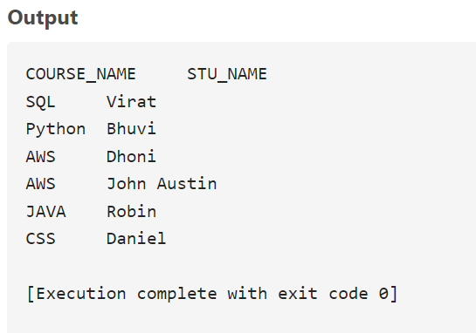

**C) Write a query to retrieve course information, including course name, instructor information**

Select * From CourseInfo;

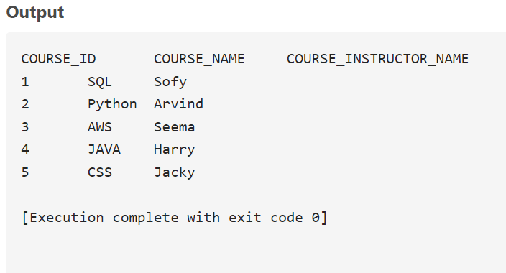

**d) Write a query to retrieve course information for a specific course**

Select COURSE_ID, COURSE_NAME, COURSE_INSTRUCTOR_NAME

from CourseInfo

where COURSE_NAME='SQL';

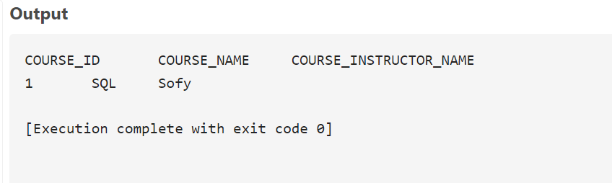

**e) Write a query to retrieve course information for multiple courses**

Select COURSE_ID,

COURSE_NAME,

COURSE_INSTRUCTOR_NAME

from CourseInfo

where COURSE_NAME in ('SQL','Python');

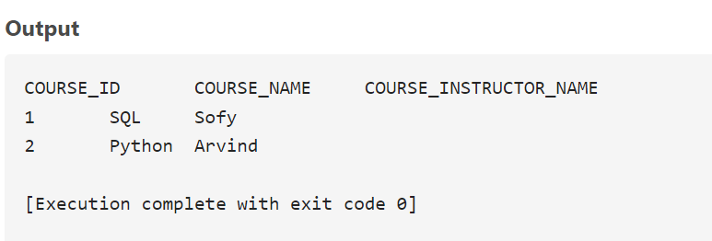

**f) Test the queries to ensure accurate retrieval of Student Information**

**(Execute queries and verify the results against the expected output)**

Select * From StudentInfo;

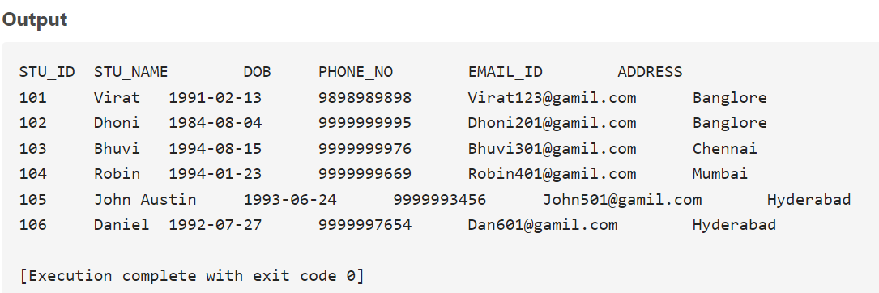

**4) Reporting and Analytics (Using joining queries)**

**a) Write a query to retrieve the number of students enrolled in each course**

Select c.Course_Name ,

count(c.course_id) as numberofStudents

from CourseInfo c join EnrollmentInfo e

on c.course_id=e.course_ID

where e.enroll_status = 'ENROLLED'

group by 1;

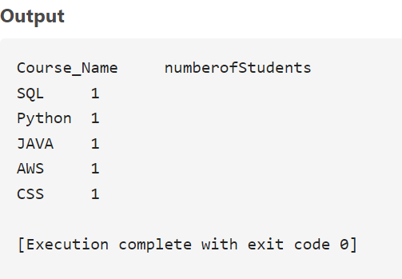

**b) Write a query to retrieve the list of students enrolled in a specific course**

select e.COURSE_ID,

c.COURSE_NAME,

s.STU_NAME

from CourseInfo c join EnrollmentInfo e on c.course_id=e.course_ID

join StudentInfo s on s.STU_ID = e.STU_ID where e.enroll_status = 'ENROLLED';

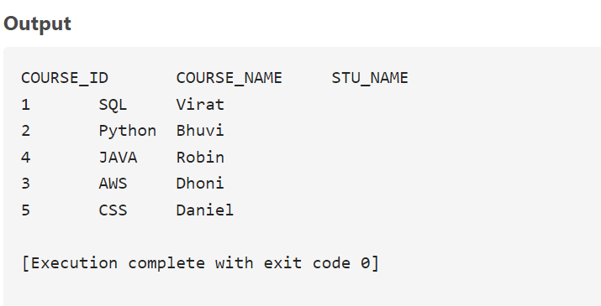

**c) Write a query to retrieve the count of enrolled students for each instructor**

Select c.COURSE_INSTRUCTOR_NAME , count(e.Stu_id) as numberofStudents

from CourseInfo c join EnrollmentInfo e

on c.course_id=e.course_ID

where e.enroll_status = 'ENROLLED'

group by 1;

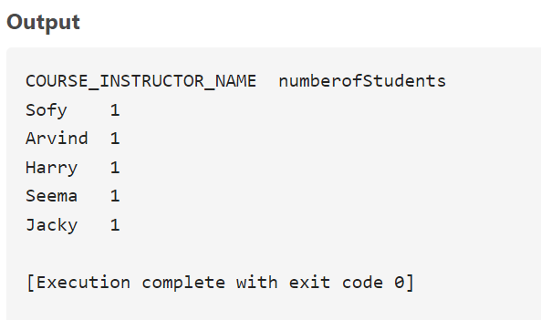

**d) Write a query to retrieve the list of students who are enrolled in a multiple course**

Select e.stu_id , count(c.course_id) as numberofStud

from CourseInfo c join EnrollmentInfo e

on c.course_id=e.course_ID

where e.enroll_status = 'ENROLLED'

group by 1

having count(c.course_id) >1

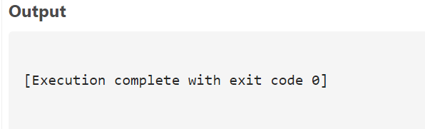

**e) Write a query to retrieve the courses that have the highest number of enrolled students(arranging from highest to lowest)**

Select e.stu_id , count(c.course_id) as numberofStud

from CourseInfo c join EnrollmentInfo e

on c.course_id=e.course_ID

where e.enroll_status = 'ENROLLED'

group by 1

having count(c.course_id) >1

order by count(c.course_id) desc



**Task 2: Student Database Management System(Postgresql)**

-- Database: Student_Database

-- DROP DATABASE IF EXISTS "Student_Database";

**1) Database setup**

CREATE DATABASE "Student_Database"

WITH

OWNER = postgres

ENCODING = 'UTF8'

LC_COLLATE = 'English_United States.1252'

LC_CTYPE = 'English_United States.1252'

TABLESPACE = pg_default

CONNECTION LIMIT = -1

IS_TEMPLATE = False;

create table Student_table

(Student_id int, Stu_name varchar(100), Department varchar(50), email_id varchar(50),

Phone_no numeric, Address varchar(250), Date_Of_Birth DATE, Gender Varchar(30),

Major Varchar(50), GPA numeric, Grade varchar(10));

**2) Data entry**

Insert Into Student_table

(Student_id, Stu_name, Department, email_id, Phone_no, Address, Date_Of_Birth, Gender, Major,

GPA, Grade) Values

('1', 'Pravalika Gourishetty', 'Business', 'PravalikaG@gmail.com', '9999999991', 'Delhi', '1999-04-26', 'Female', 'MBA', '8.8', 'A'),

('2', 'Krishna Kumar', 'Arts and Sciences', 'krishnakumar@gmail.com', '9999999992', 'Bangalore', '1992-07-15', 'Male', 'Mathematics', '8.6', 'A'),

('3', 'Ravi Nema', 'Business', 'Ravinema@gmail.com', '9999999993', 'Delhi', '1995-06-28', 'Male', 'MBA', '8.5', 'A'),

('4', 'Deepa Navya', 'Arts and Sciences', 'Deepanavya@gmail.com', '9999999994', 'Dehradhun', '1997-01-12', 'Male', 'Physics', '7.6', 'B'),

('5', 'Katrina', 'Arts and communication', 'Katrina@gmail.com', '9999999995', 'Mumbai', '1995-10-26', 'Female', 'Communication', '6.9', 'B'),

('6', 'Santosh', 'Arts and Sciences', 'Santosh@gmail.com', '9999999996', 'Goa', '2000-01-03', 'Female', 'Computer Science', '5.5', 'C'),

('7', 'Hima', 'Human Development', 'Hima@gmail.com', '9999999997', 'Uttar Pradesh', '2000-10-05', 'Male', 'Counseling', '7.0', 'B'),

('8', 'Pranavi Yadav', 'Arts and communication', 'Pranavi@gmail.com', '9999999998', 'Gujarat', '1999-11-16', 'Male', 'Theatre', '9.2', 'A'),

('9', 'Sampath', 'Business', 'Sampath@gmail.com', '9999999999', 'Rajasthan', '2003-08-14', 'Male', 'Accounting', '7.9', 'B'),

('10', 'Sandhya', 'Arts and Sciences', 'Sandhya@gmail.com', '9999999911', 'Mumbai', '1997-03-12', 'Female', 'Physics', '4.9', 'C');

Select * from Student_table;

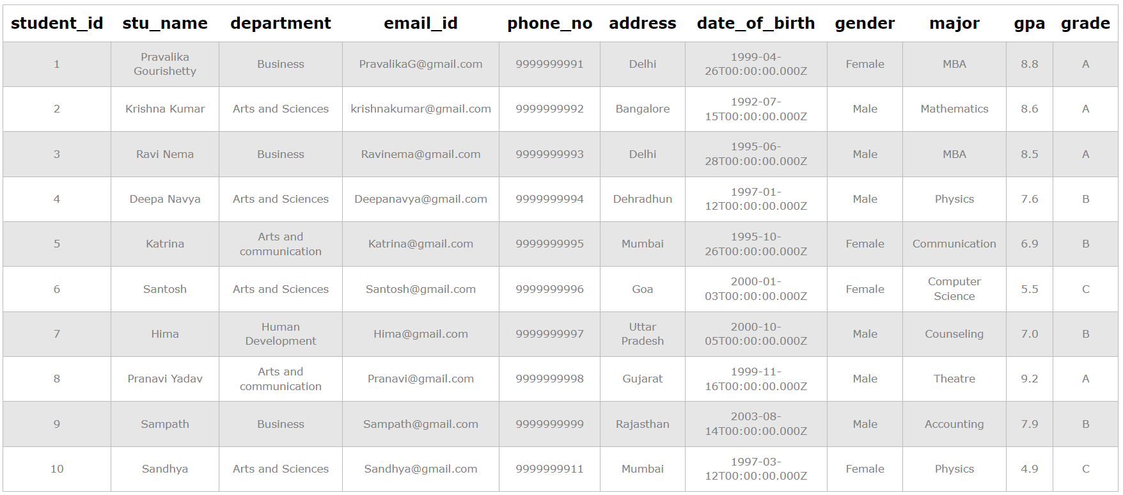

**3) Student information retrieval**

Select * from Student_table

Order By GPA desc, Grade;

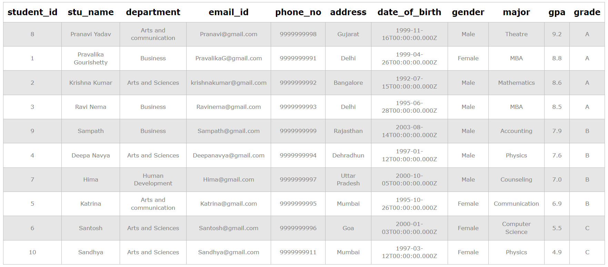

**4) Male students**

Select * from Student_table

where Gender = 'Male';

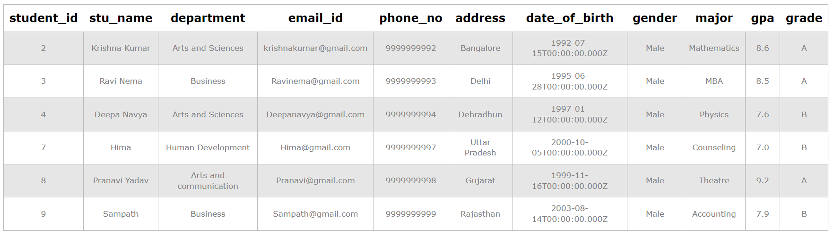

**5) GPA less than 5**

Select * from Student_table

where GPA <5.0;



**6) Update email_id and Grade**

UPDATE Student_table

SET email_id = 'Sarada@gmail.com', Grade = 'D'

Where Student_id = '9';



**7) Grade B**

SELECT Stu_name, date_part('year',age(Date_Of_Birth)) as Age

FROM Student_table

Where Grade = 'B';

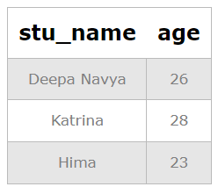

**8) Grouping and calculation**

Select Department, Gender, Avg(GPA)

From Student_table

Group By 1,2;

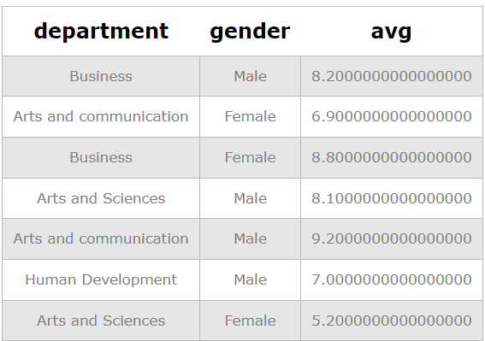

**9) Renaming**

Alter table Student_table

Rename to Student_info;

Select * from Student_info;

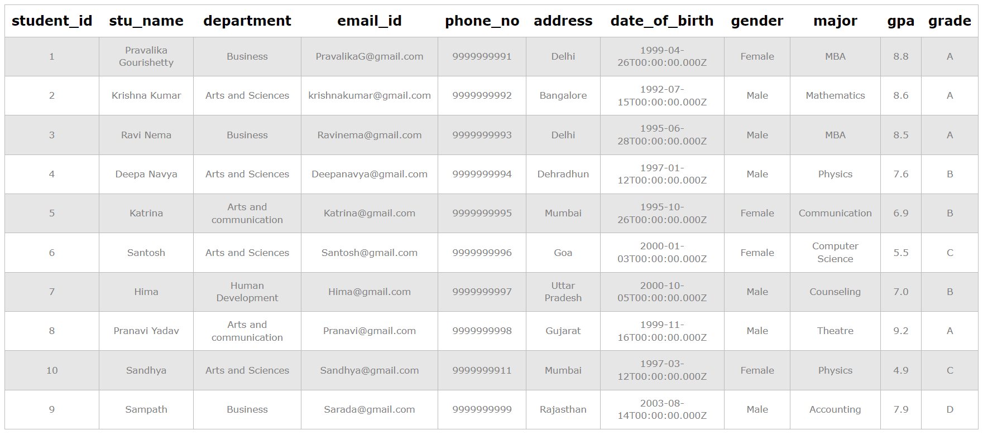

**10) Students with highest GPA**

Select Stu_name, GPA

From Student_info where GPA = (Select Max(GPA) From Student_info);

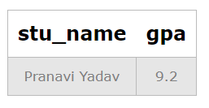

**Task 3: Event Management Sysytem (Postgresql)**

-- Database: EventsManagement

-- DROP DATABASE IF EXISTS "EventsManagement";

CREATE DATABASE "EventsManagement"

WITH

OWNER = postgres

ENCODING = 'UTF8'

LC_COLLATE = 'English_United States.1252'

LC_CTYPE = 'English_United States.1252'

TABLESPACE = pg_default

CONNECTION LIMIT = -1

IS_TEMPLATE = False;

**1) Database Creation**

Create table Events (

Event_Id Int,

Event_Name Varchar(30),

Event_Date Date,

Event_Location Varchar(100),

Event_Description Varchar(200),

primary key (Event_Id));

Create table Attendees (

Attendee_Id Int,

Attendee_Name Varchar(30),

Attendee_Phone numeric,

Attendee_Email Varchar(30),

Attendee_City Varchar(20),

primary key (Attendee_Id));

Create table Registrations (

Registration_Id Int,

Event_Id Int,

Attendee_Id Int,

Registration_Date Date,

Registration_Amount numeric,

primary key (Registration_Id),

FOREIGN KEY (Event_Id) REFERENCES Events(Event_Id),

FOREIGN KEY (Attendee_Id) REFERENCES Attendees(Attendee_Id));

**2) Data Creation**

Insert into Events

(Event_Id, Event_Name, Event_Date, Event_Location, Event_Description) values

('101', 'Taylor swift', '2024-01-08', 'Mumbai', 'Music Show'),

('102', 'Comicon', '2023-11-23', 'Bangalore', 'Exhibition'),

('103', 'IIMF', '2023-11-12', 'Hyderabad', 'Music Show'),

('104', 'Hitcki', '2024-03-06', 'Kochi', 'Comedy'),

('105', 'Ted Talk', '2024-02-23', 'Kolkata', 'Comedy')

;

Select * from Events;

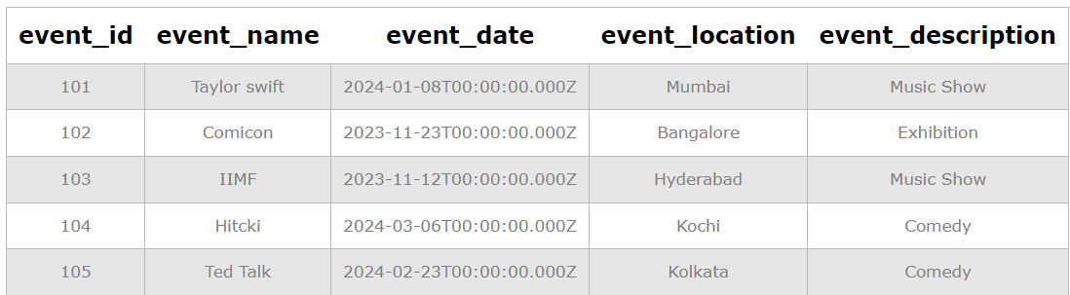

Insert into Attendees (Attendee_Id, Attendee_Name, Attendee_Phone, Attendee_Email, Attendee_City) values

('1001', 'Pravalika', '9999999991', 'Pravalika@gmail.com', 'Hyderabad'),

('1002', 'Raj kumar', '9999999992', 'Raj@gmail.com', 'Delhi'),

('1003', 'Abhiram', '9999999993', 'Abhiram@gmail.com', 'Mumbai'),

('1004', 'Kumar', '9999999994', 'Kumar@gmail.com', 'Uttar Pradesh'),

('1005', 'Katty', '9999999995', 'Katty@gmail.com', 'Mumbai'),

('1006', 'Shiv', '9999999996', 'Shiv@gmail.com', 'Goa'),

('1007', 'Dinesh', '9999999997', 'Dinesh@gmail.com', 'Uttrakhand'),

('1008', 'Sarthak', '9999999998', 'Sarthak@gmail.com', 'Delhi')

;

Select * from Attendees;

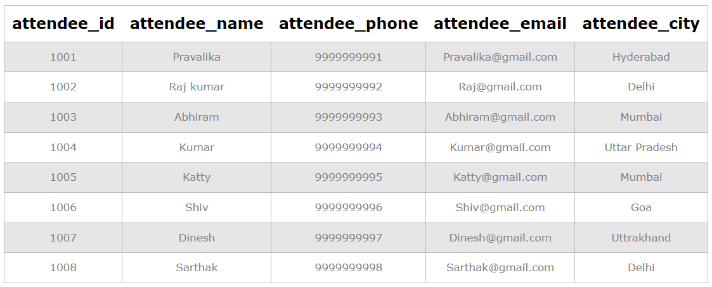

Insert into Registrations

(Registration_Id, Event_Id, Attendee_Id, Registration_Date, Registration_Amount) values

('10001', '101', '1001', '2024-01-08', '7500'),

('10002', '102', '1003', '2023-09-25', '1000'),

('10003', '103', '1002', '2023-10-29', '2000'),

('10004', '104', '1004', '2023-10-20', '500'),

('10005', '101', '1005', '2023-09-10', '7500'),

('10006', '103', '1008', '2023-09-15', '2000'),

('10007', '101', '1007', '2023-11-23', '7500'),

('10008', '102', '1006', '2023-11-12', '1000')

;

Select *from Registrations;

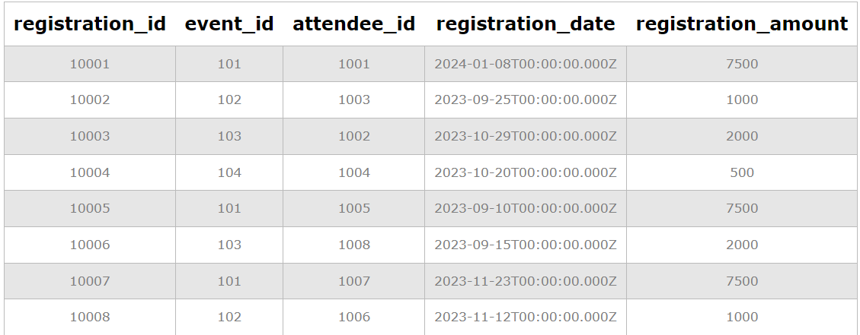

**3) Manage Event Details**

**a) Insert New event**

Insert INTO Events (Event_Id, Event_Name, Event_Date, Event_Location, Event_Description) VALUES

('106', 'Untold Stories', '2023-11-19', 'Delhi', 'Storytelling');

**b) Update event's information**

UPDATE Events

SET Event_Location = 'Bangalore' Where Event_Id = '104'

;

**c) Deleting an event**

Delete from Events where Event_Id = '105'

;

**4) Manage Track attendees and handle events**

**a) Insert new attendee**

Insert into Attendees (Attendee_Id, Attendee_Name, Attendee_Phone, Attendee_Email, Attendee_City)

values ('1009', 'Kavitha', '9999999999', 'Kavitha@gmail.com', 'Hyderabad');

**b) Register attendee**

Insert into Registrations (Registration_Id, Event_Id, Attendee_Id, Registration_Date, Registration_Amount)

values ('10009', '101', '1009', '2023-11-11', '7500');

**5) Retrieve event information, Generate attendee list, Calculate event attendee statistics**

Select * from Events;

Select * from Attendees;

select * from Registrations;

with Event1 as(

select E.Event_id, E.event_name, E.event_date, E.event_location,

sum(R.registration_amount) over(partition by E.event_id) as Amountgenperevent

from Events E join Registrations R on E.event_id = R.event_id

join Attendees A on A.attendee_id = R.attendee_id)

select Event_id, event_name, event_location, Amountgenperevent

from Event1

group by 1,2,3,4

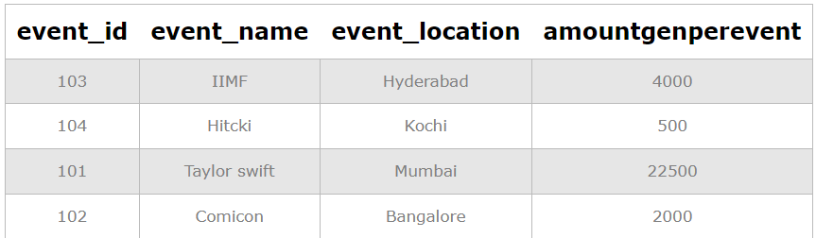

**Task 4: OLAP Operations (Postgresql)**

-- Database: Sales Data

-- DROP DATABASE IF EXISTS "Sales Data ";

CREATE DATABASE "Sales Data "

WITH

OWNER = postgres

ENCODING = 'UTF8'

LC_COLLATE = 'English_United States.1252'

LC_CTYPE = 'English_United States.1252'

TABLESPACE = pg_default

CONNECTION LIMIT = -1

IS_TEMPLATE = False;

**1) Database creation**

Create table Sales_sample (Product_Id Int, Region Varchar(50), On_date Date,

Sales_Amount Numeric);

**2) Data Creation**

Insert into Sales_sample (Product_Id, Region, On_date, Sales_Amount) values

('1', 'East', '2023-11-10', '20000'),

('2', 'West', '2023-08-19', '50000'),

('2', 'East', '2023-11-21', '40000'),

('3', 'North', '2023-07-20', '15000'),

('4', 'North', '2023-08-07', '45000'),

('2', 'South', '2023-08-24', '45000'),

('5', 'North', '2023-11-22', '20000'),

('5', 'West', '2023-11-11', '60000'),

('3', 'East', '2023-09-19', '50000'),

('1', 'West', '2023-09-29', '70000')

;

Select * from Sales_Sample;

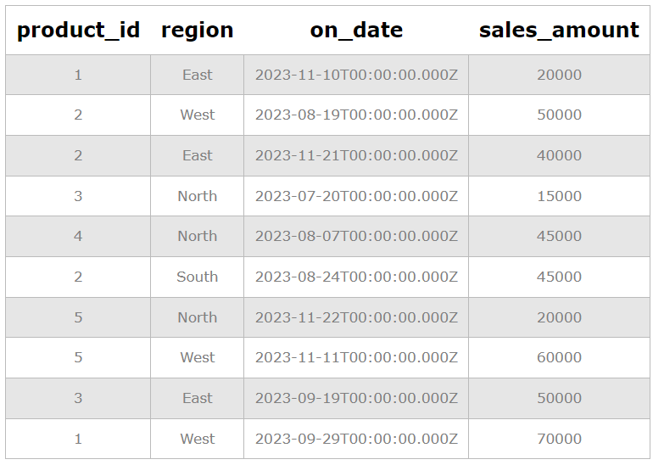

**3) OLAP operations**

**a) Drill down**

Select Region, Product_Id, Sum(Sales_Amount) as Sales_Amount

From Sales_Sample

Group By 1,2

Order By Region, Product_Id, Sales_Amount;

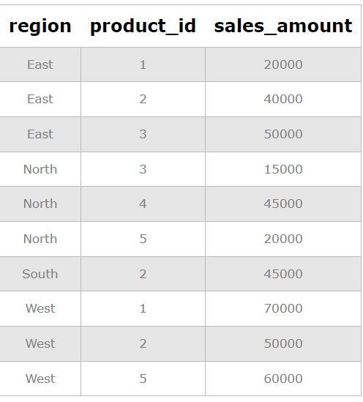

**b) Roll Up**

Select Region, Product_Id, Sum(Sales_Amount) as Sales_Amount

From Sales_Sample

Group By Rollup (1,2)

Order By Region;

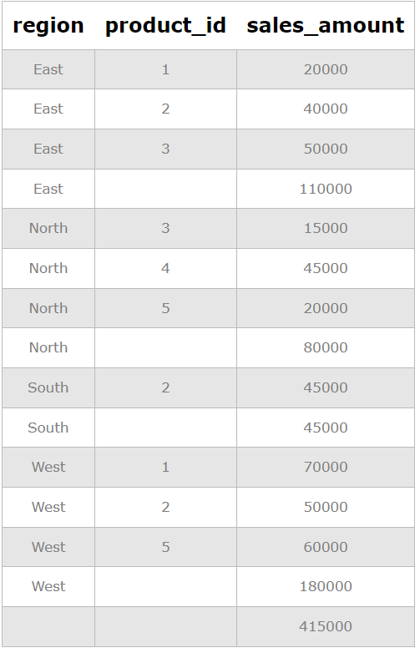

**c) Cube**

Select Region, Product_Id, On_Date, Sum(Sales_Amount) as Sales_Amount

From Sales_Sample

Group By Cube (1,2,3)

Order By Region, Product_Id, On_Date, Sales_Amount;

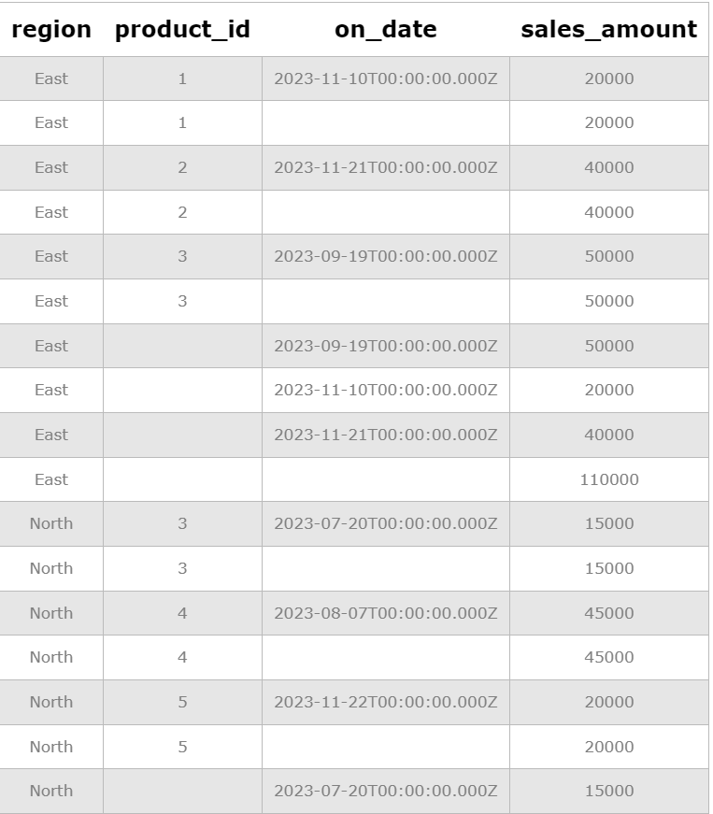

**d) Slice**

Select Region, Product_Id, On_Date, Sum(Sales_Amount) as Sales_Amount

From Sales_Sample

Where Region in('North', 'South') OR On_Date between To_date('2023-08-20','YYYY-MM-DD') And To_Date('2023-10-20','YYYY-MM-DD')

Group By 1,2,3

Order By Region, Product_Id, On_Date, Sales_Amount;

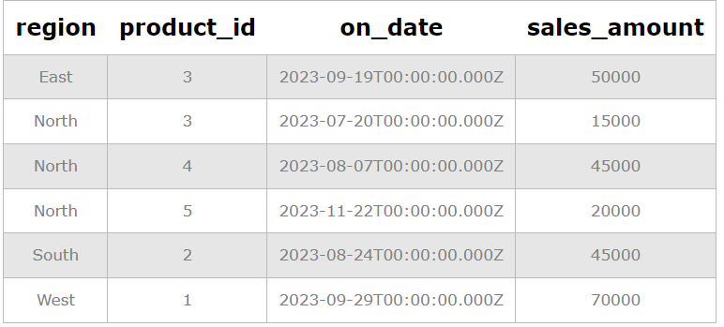

**e) Dice**

Select Region, Product_Id, On_Date, Sum(Sales_Amount) as Sales_Amount

From Sales_Sample

Where Region in('North', 'South') AND Product_Id IN (1,2) AND On_Date between To_date('2023-08-20','YYYY-MM-DD') And To_Date('2023-10-20','YYYY-MM-DD')

Group By 1,2,3

Order By Region, Product_Id, On_Date, Sales_Amount;

